Lab - Installing the IPv6 Protocol and Assigning Host Addresses with Windows XP

1. Objectives

Part 1: Install the IPv6 Protocol on a Windows XP PC

* Install the IPv6 protocol.
* Examine IPv6 address information.

Part 2: Use the Network Shell (netsh) Utility

* Work inside the **netsh** utility.
* Configure a static IPv6 address on the local-area network (LAN) interface.
* Exit the **netsh** utility.
* Display IPv6 address information using **netsh**.
* Issue **netsh** instructions from the command prompt.

1. Background / Scenario

The Internet Protocol Version 6 (IPv6) is not enabled by default in Windows XP. Windows XP includes IPv6 implementation, but the IPv6 protocol must be installed. XP does not provide a way to configure IPv6 static addresses from the Graphical User Interface (GUI), so all IPv6 static address assignments must be done using the Network Shell (**netsh**) utility.

In this lab, you will install the IPv6 protocol on a Windows XP PC. You will then assign a static IPv6 address to the LAN interface.

1. Required Resources

1 Windows XP PC

1. Install the IPv6 Protocol on a Windows XP PC

In Part 1, you will install the IPv6 protocol on a PC running Windows XP. You will also use two commands to view the IPv6 addresses assigned to the PC.

* 1. Install the IPv6 protocol.

From the command prompt window, type **ipv6 install** to install the IPv6 protocol.

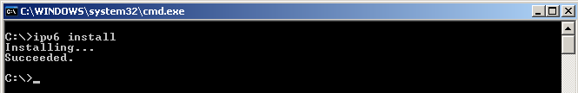

* 1. Examine IPv6 Address Information.

Use the **ipconfig /all** command to view IPv6 address information.

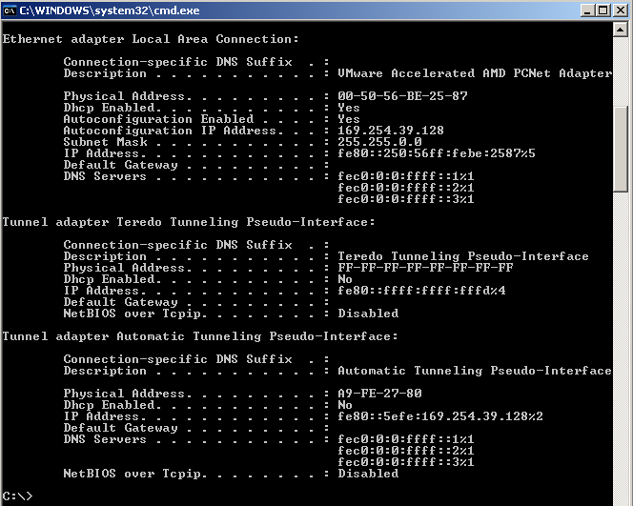

1. Use the Network Shell (netsh) Utility

Network Shell (**netsh**) is a command-line utility included with Windows XP and newer Windows operating systems, such as Vista and Windows 7. It allows you to configure the IPv6 address information on your LAN. In Part 2, you will use the **netsh** utility to configure static IPv6 address information on a Windows XP PC LAN interface. You will also use the **netsh** utility to display the PC LAN interface IPv6 address information.

* 1. Work inside the Network Shell utility.
     1. From the command prompt window, type **netsh** and press Enter to start the **netsh** utility. The command prompt changes from **C:\>** to **netsh>**.

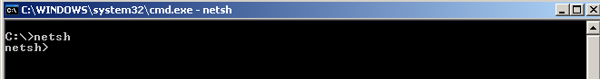

* + 1. At the prompt, enter a question mark (**?**) and press Enter to provide the list of available parameters.

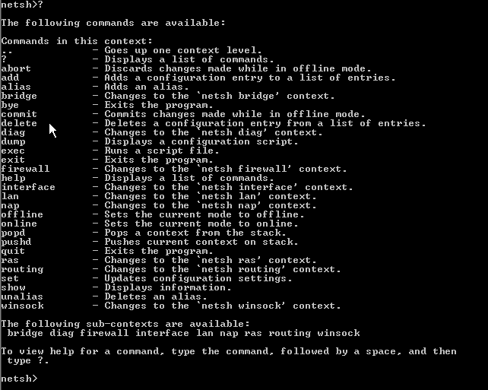

* + 1. Type **interface ?** and press Enter to provide the list of interface commands.

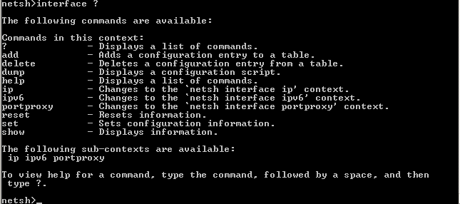

**Note**: You can use the question mark (**?**) at any level in the **netsh** utility to list the available options. The up arrow can be used to scroll through previous **netsh** commands. The **netsh** utility also allows you to abbreviate commands, as long as the abbreviation is unique.

* 1. Configure a static IPv6 address on the LAN interface.

To add a static IPv6 address to the LAN interface, issue the **interface ipv6 add address** command from inside the **netsh** utility.



* 1. Display IPv6 address information using the netsh utility.

You can display IPv6 address information using the **interface ipv6 show address** command.

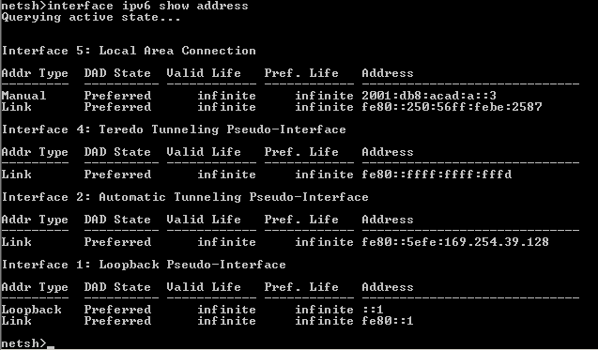

* 1. Exit the netsh utility.

Use the **exit** command to exit from the **netsh** utility.



* 1. Issue netsh instructions from the command prompt.

All **netsh** instructions can be entered from the command prompt, outside the **netsh** utility, by preceding the instruction with the **netsh** command.

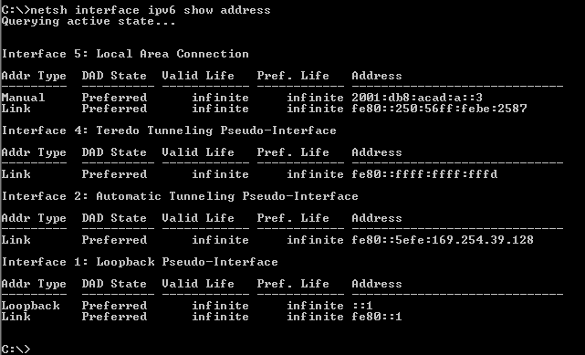

1. Reflection
   1. How would you renew your LAN interface address information from the **netsh** utility?

**Hint**: Use the question mark (**?**) for help in obtaining the parameter sequence.

_______________________________________________________________________________________

_______________________________________________________________________________________